**Terraria Invader**

**Created by**

Khatchaphong Chantarote 6130058121

Pakkapon Wattanawaha 6130391021

**2110215 Programming Methodology Semester 1 Year 2019 Chulalongkorn University**

**TerrariaInvader**

**Introduction**

Terraria invader is inspired by an all-time famous 2-dimensions shooting game “Space invader” shown in a theme of “Terraria”. Objectives of the game is “surviving and boss fighting”. In this game, you will act as a “Super Slime with an arrow-shooting umbrella”. The story began when “The wall of flesh”, the highest entities in Terrarian World, banishes you after it found out that you were on a date with it’s daughter. With your desired of vengeance, you seek for revenge.

**Objectives**

Like from the earlier, objectives of the game is to kill all the boss while staying alive. There are various of power ups to help you proceed with your journey ,but if you die before the boss is, distances of your run will indicate how good you are at surviving. But the greatest player never knows how to die, so finding yourself kills the boss with a shortest distance could be more challenging for a real gamer.

**In Game Footage**

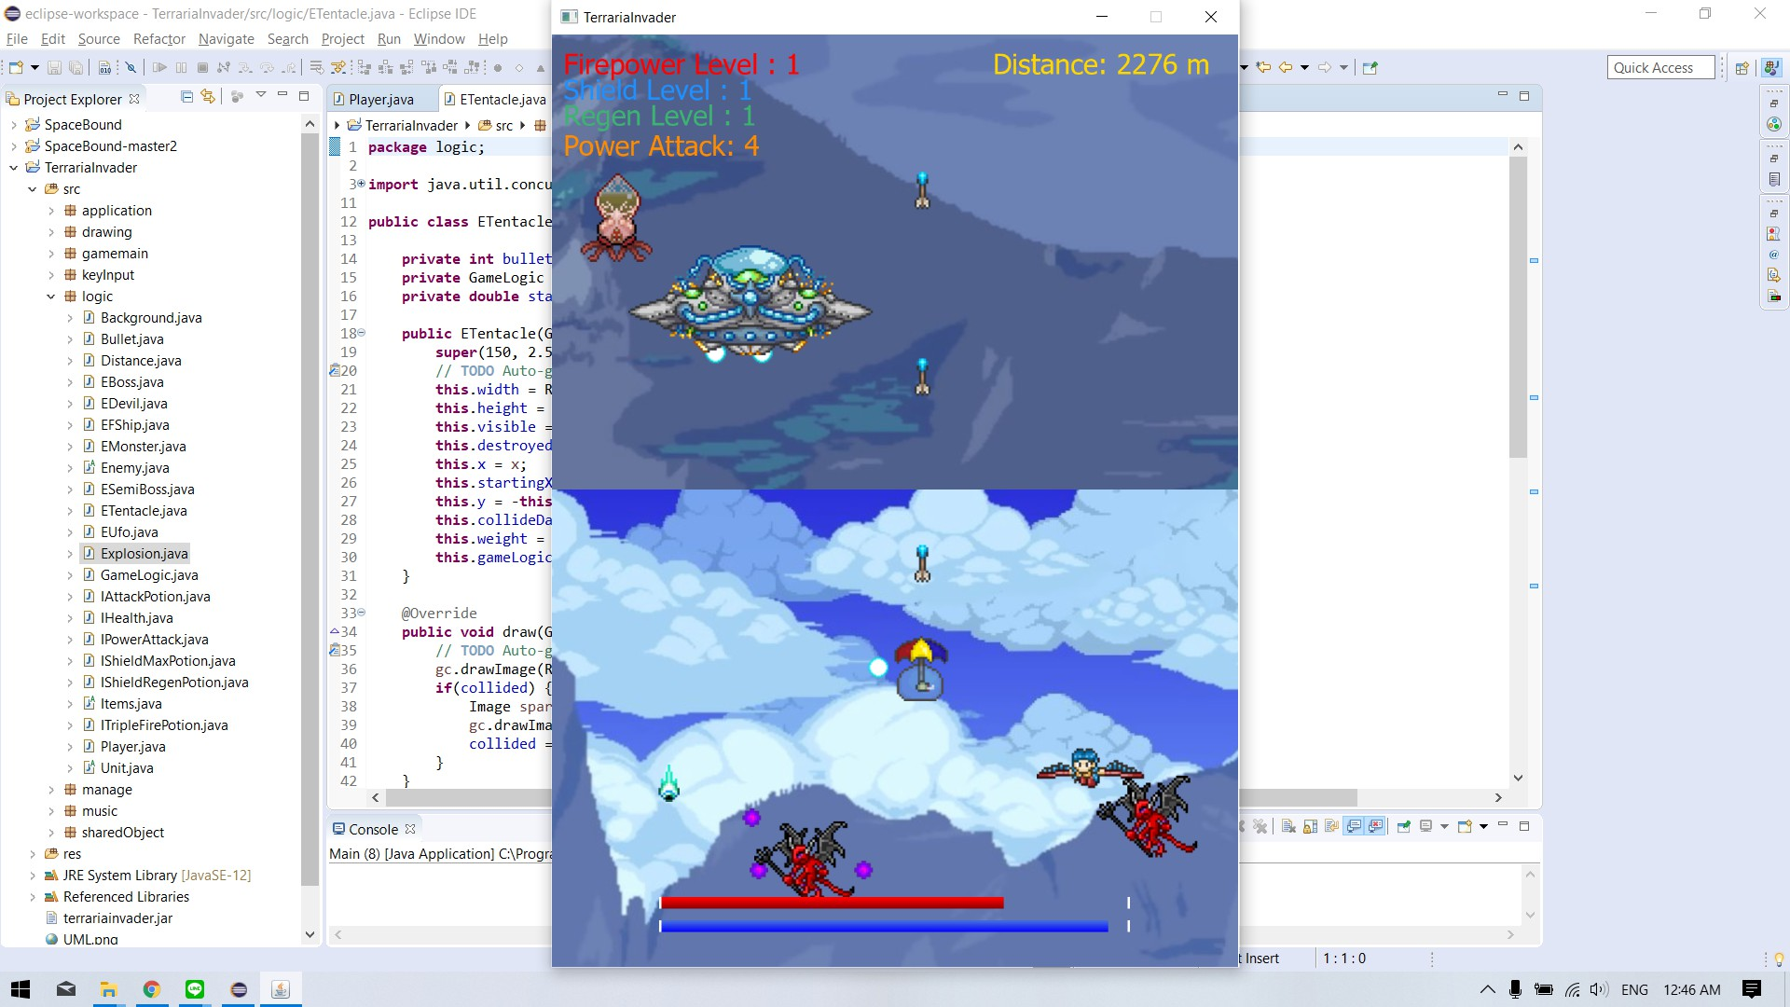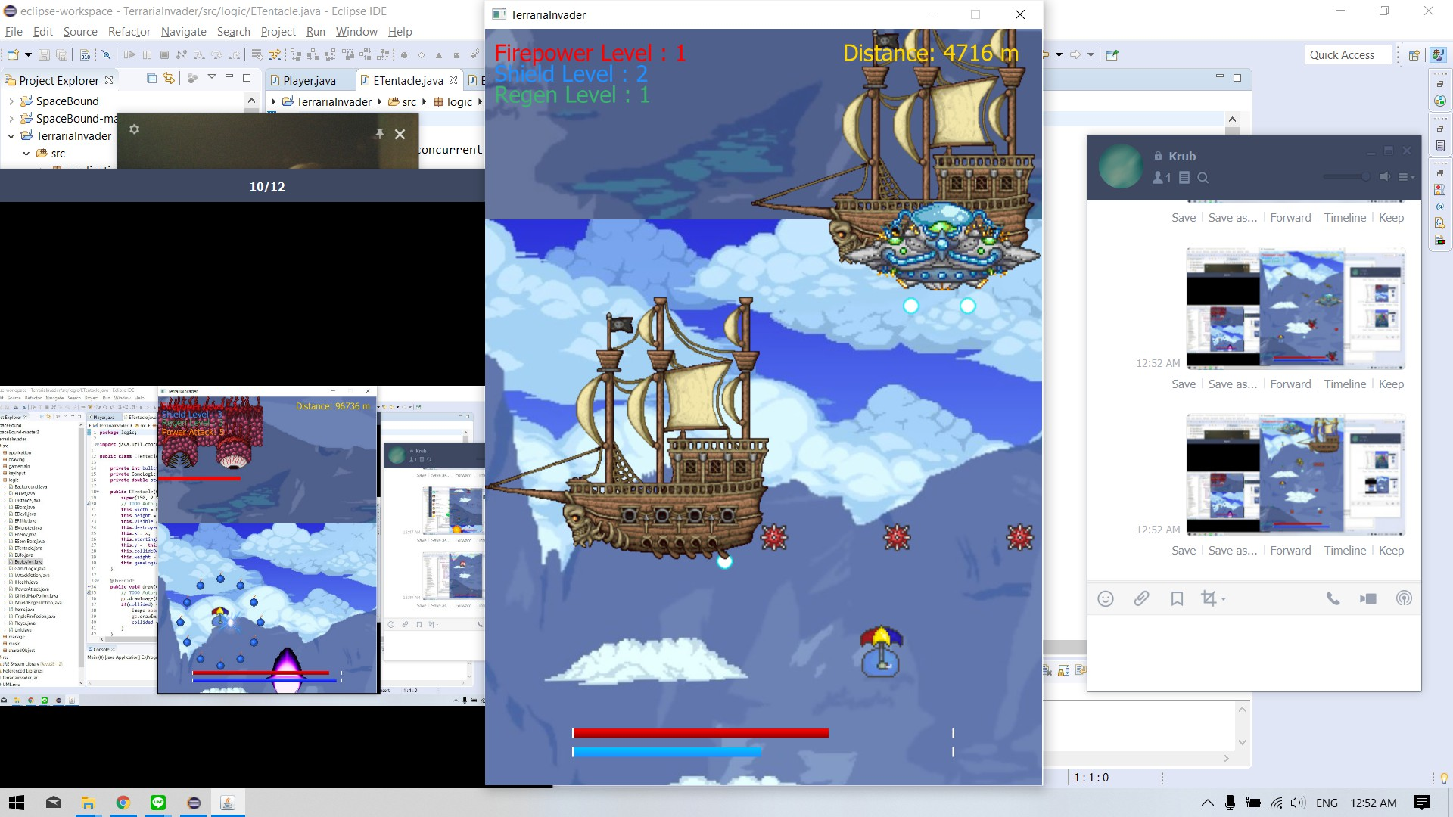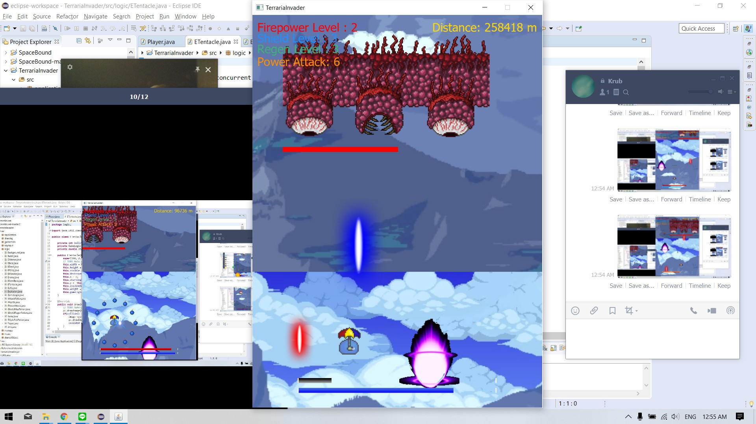

**Controls**



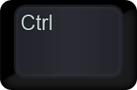  

Arrow Keys - For maneuvering around

Spacebar - Shoot

Ctrl - Use Power Attack

**MainMenu Screen**

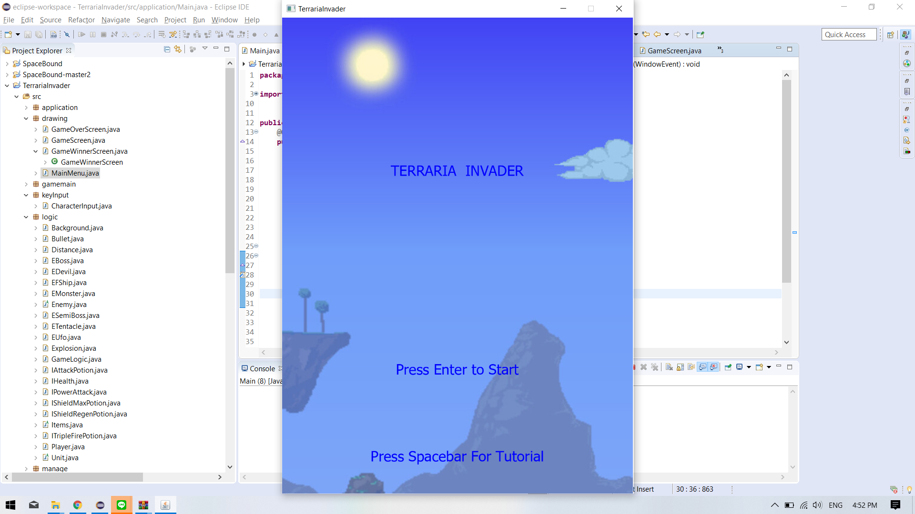

Press Enter to Start the Game

Press Space For Tutorial

**Powerups**

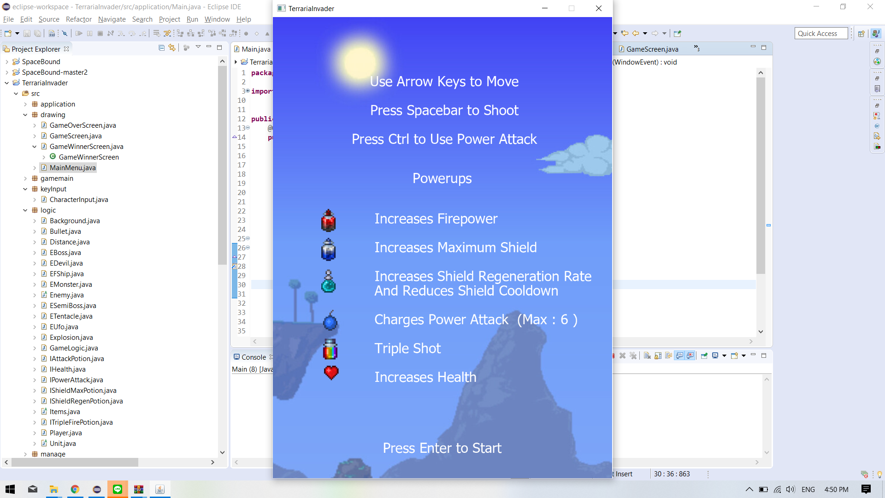

**Class Diagram**

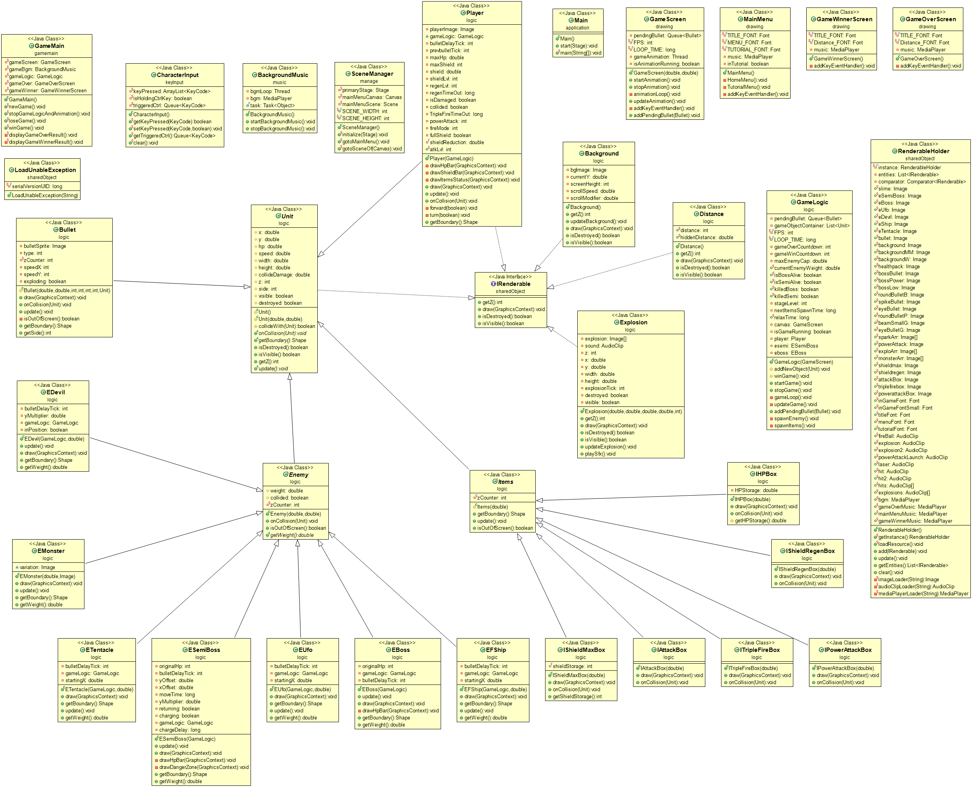

**Package : sharedObject**

1.1 interface IRenderable

1.1.1 Methods

|  |  |
| --- | --- |
| +int getZ() | Return the dimension z of the object // z is used on sorting such that no two objects are collapsed while rendering |
| +void draw(GraphicsContext gc) | Draw image on gc |
| +boolean isDestroyed() | Return true if the object is destroyed  else return false |
| +boolean isVisible() | Return true if object is visible  else return false |

1.2 class RoadUnableException extends Exception

1.2.1 Constructor

|  |  |
| --- | --- |
| +LoadUnableException(String message) | Throws error when the resource message can’t be loaded |

1.3 class RenderableHolder

1.3.1 Fields

|  |  |
| --- | --- |
| -static final RenderableHolder instance | instance = new RenderableHolder() |
| -List<IRenderable> entities | Contains all entities in the game |
| -Comparator<IRenderable> comparator | Used to sort entities in the list above by their member’s coordinate z |
| + static Image slime, eSemiBoss, eBoss, eUfo, eDevil, eShip, eTentacle, bullet, background,  backgroundMM, backgroundW, healthpack, bossBullet, bossPower, bossLow, roundBulletB, spikeBullet, eyeBullet,  roundBulletP, beamSmallG, eyeBulletG, sparkArr[], powerAttack, exploArr[], monsterArr[], shieldmax,  shieldregen, attackPotion, triplefire, powerattack | contains all image required in game |
| + static Font inGameFont, inGameFontSmall, titleFont, menuFont, tutorialFont | contains all font required in game |
| + static AudioClip fireBall, explosion, explosion2, powerAttackLaunch, laser, hit, hit2 | contains all audio clip required in game |
| + static AudioClip[] hits, explosions | array that contains audio clip required in game |
| + static MediaPlayer bgm, gameOverMusic, mainMenuMusic, gameWinnerMusic | contains all media player required in game |

1.3.2 Constructor

|  |  |
| --- | --- |
| +RenderableHolder() | Initializes entities and comparator |

1.3.3 Methods

|  |  |
| --- | --- |
| +static getInstance() | Return instance |
| +static loadResource() | Load all resources from res and assign into fields |
| +void add(IRenderable entity) | Add entity into entities and sort |
| +void update() | Remove all destroyed members in entities |
| +List<IRenderable> getEntities() | Return entities |
| +void clear() | Remove all members in entities |
| -static Image imageLoader(String url) | Load image from url |
| -static AudioClip audioClipLoader(String url) | Load audio clip from url |
| -static MediaPlayer mediaPlayerLoader(String url) | Load media player from url |

**Package : logic**

2.1 class Background implements IRenderable

2.1.1 Fields

|  |  |
| --- | --- |
| -Image bgImage | bgImage = null |
| -double currentY | Coordinate y of a background image |
| -int screenHeight | The height of background |
| -double scrollSpeed | How fast background image is scrolling down the screen |
| -double scrollModifier | Used to adjust scrolling speed |

2.1.2 Constructor

|  |  |
| --- | --- |
| +Background() | Set bgImage  Set currentY = 0 |

2.1.3 Methods

|  |  |
| --- | --- |
| +int getZ() | return Integer.MIN_VALUE since the background has to be on the bottom |
| +void draw(GraphicContext gc) | If bgImage has initialized  -draw background on gc  else do nothing |
| +boolean isDestroyed | return false |
| +boolean isVisible | return true |
| +void updateBackground() | Scroll the background down and if the coordinate y of the background exceeding its height, redraw the background from y=0 |

2.2 abstract class Unit implements IRenderable

2.2.1 Fields

|  |  |
| --- | --- |
| #double x | Coordinate x of unit |
| #double y | Coordinate y of unit |
| #double hp | Hp of unit |
| #double speed | Speed of unit in y axis |
| #double width | Unit’s width |
| #double height | Unit’s height |
| #double collideDamage | Damage this unit deal when collided |
| #int z | Coordinate z of unit |
| #int side | direction which unit is facing  1 means unit is facing up along y axis  -1 means unit is facing down along y axis |
| #boolean visible | Is a unit visible or not |
| #boolean destroyed | Is a unit get destroyed or not |

2.2.2 Constructor

|  |  |
| --- | --- |
| #Unit() | initializes unit with hp = 100  and speed = 20  set visible and destroyed |
| #Unit(double hp, double speed) | initializes unit with this.hp = hp  and this.speed = speed  set visible and destroyed |

2.2.3 Methods

|  |  |
| --- | --- |
| # boolean collideWith(Unit other) | Logic which checks if a unit take an effect from the collision with any other unit |
| + abstract void onColision(Unit other) | Logic when any unit is colliding with other |
| + abstract Shape getBoundary() | return shape of a unit |
| + boolean isDestroyed | return destroyed |
| + boolean isVisible | return visible |
| + int getZ() | return z |
| + abstract void update() | update data of unit |

2.3 abstract class Enemy extends Unit

2.3.1 Fields

|  |  |
| --- | --- |
| # double weight | How strong a unit is |
| # boolean collided | Is a unit on collision |
| - static int zCounter | zCounter = 200 when first initialize |

2.3.2 Constructor

|  |  |
| --- | --- |
| + Enemy(double hp, double speed) | -initializes super with hp and speed  -set side = -1  -set z  -change zCounter to make sure that no other enemy is on the same coordinate and make sure it is in range [-200,-100) |

2.3.3 Methods

|  |  |
| --- | --- |
| + void onCollision(Unit others) | Logic on checking if a collision effects unit or not when a unit is colliding with others |
| + boolean isOutOfScreen() | return true if unit is out of screen  else return false |
| + abstract double getWeight() | return weight of a unit |

2.4 abstract class Items extends Unit

2.4.1 Fields

|  |  |
| --- | --- |
| - static int zCounter | zCounter = -1150 and must always be in range [-1150,1100) |

2.4.2 Constructor

|  |  |
| --- | --- |
| # Items(double speed) | -initializes super with hp = 1 and speed  -set side = -1  -set z and make sure zCounter is valid when construting new Item |

2.4.3

|  |  |
| --- | --- |
| + Shape getBoundary() | Return a Rectangle shape represents an item’s boundary |
| + void update() | Updates data of an item |
| + isOutOfScreen() | return true if an item is out of screen  else return false |

2.5 class Bullet extends Unit

2.5.1 Fields

|  |  |
| --- | --- |
| - Image bulletSprite |  |
| - int type | type of a bullet |
| - static int zCounter | zCounter = -700 and always be in range [-1100,300) |
| - int speedX,speedY | speed of bullet in coordinate x and y |
| - boolean exploding | exploding = false |

2.5.2 Constructor

|  |  |
| --- | --- |
| # Bullet(double x, double y, int speedX, int speedY, int side, int type, Unit e) | -initializes super and others required field  -set bulletSprite by type  -make sure zCounter valid for the next time you constructs bullet |

2.5.3 Methods

|  |  |
| --- | --- |
| + void draw(GraphicContext gc) | draws bulletSprite on gc with its current coordinate |
| + void onCollision(Unit others) | logic of when a bullet is collide |
| + void update() | update data of a bullet |
| - boolean isOutOfScreen() | return true if a bullet is out of screen |
| + Shape getBoundary() | return rectangle or circle shape of bullet by its type |
| + int getSide | return side |

2.6 class Distance implements IRenderable

2.6.1 Fields

|  |  |
| --- | --- |
| + static int distance | The distance shown in game screen |
| + static double hiddenDistance | The real distance |

2.6.2 Constructor

|  |  |
| --- | --- |
| + Distance() | set distance and hiddenDistance to 0 |

2.6.3 Methods

|  |  |
| --- | --- |
| + void draw(GraphicContext gc) | draw distance on gc |
| + boolean isDestroyed() | return false |
| + boolean isVisible() | return true |
| + int getZ() | return Integer.MAX_VALUE  since distance must be on top of other entities |

2.7 class Eboss extends Enemy

2.7.1 Fields

|  |  |
| --- | --- |
| - int originalHp | Original hp of a boss |
| - GameLogic gameLogic | a GameLogic which boss is in |
| - int bulletDelayTick | bulletDelayTick = 0  time delay between each bullet shot |

2.7.2 Constructor

|  |  |
| --- | --- |
| + EBoss(GameLogic gameLogic) | -initializes super and other required fields  -set isBossAlive = true in gameLogic |

2.7.3 Methods

|  |  |
| --- | --- |
| + void update() | update data of boss, logic of bullet shooting and special move |
| + void draw(GraphicContext gc) | draw boss on gc |
| - void drawHpBar(GraphicContext gc) | draw boss hp on gc |
| + Shape getBoundary() | Return a rectangle shape of boss |
| + double getWeight() | return weight |

2.8 class EDevil extends Enemy

2.8.1 Fields

|  |  |
| --- | --- |
| - int bulletDelayTick | bulletDelayTick = 0  time delay between each bullet shot |
| - double yMultiplier | devil will hold itself at coordinate y = sceneManager.SCENE_HEIGHT*yMultiplier |
| - GameLogic gameLogic | GameLogic which devil is in |
| - boolean inPosition | true if devil is holding its position on coordinate y |

2.8.2 Constructor

|  |  |
| --- | --- |
| + EDevil(GameLogic gameLogic, double x) | -initializes super and all required fields  -set gameLogic  -random yMultiplier in range of (0.6,0.8) |

2.8.9 Methods

|  |  |
| --- | --- |
| + void update() | update data of devil, logic of bullet shooting and its unique motion |
| + void draw(GraphicContexts gc) | draw devil on gc |
| + Shape getBoundary() | return circle shape of devil |
| + double getWeight() | return weight |

2.9 class EFShip extends Enemy

2.9.1 Fields

|  |  |
| --- | --- |
| - int bulletDelayTick | bulletDelayTick = 0  time delay between each bullet shot |
| - double startingX | Coordinate x which the ship start to move (used in harmonic motion logic) |
| - GameLogic gameLogic | GameLogic which the ship is in |

2.9.2 Constructor

|  |  |
| --- | --- |
| + EFShip(GameLogic gameLogic, double x) | -initializes all required fields  -set gameLogic |

2.9.3 Methods

|  |  |
| --- | --- |
| + void update() | update data of the ship, logic of shooting and harmonic motion |
| + void draw(GraphicContexts gc) | draw the ship on gc |
| + Shape getBoundary() | return rectangle shape of the ship |
| + double getWeight() | return weight |

2.10 class EMonster extends Enemy

2.10.1 Fields

|  |  |
| --- | --- |
| Image variation | Image of a monster since there are 4 type of monster |

2.10.2 Constructor

|  |  |
| --- | --- |
| + EMonster(double x, Image i) | -set variation  -initializes all required fields based on variation |

2.10.3 Methods

|  |  |
| --- | --- |
| + void update() | update data of a monster |
| + void draw(GraphicContexts gc) | draw a monster on gc |
| + Shape getBoundary() | return rectangle shape of monster |
| + double getWeight() | return weight |

2.11 class ESemiBoss extends Enemy

2.11.1 Fields

|  |  |
| --- | --- |
| - int originalHp | semiBoss maximum hp |
| - int bulletDelayTick | bulletDelayTick = 0  time delay between each bullet shot |
| - double yOffset | save coordinate y before special move |
| - double xOffset | save coordinate x before special move |
| - long moveTime | uses in harmonic motion |
| - double yMultiplier | special attack height |
| - boolean returning | true if semiBoss is returning after it uses special attack  else false |
| - boolean charging | false if semiBoss is ready to use special attack  else true |
| - GameLogic gameLogic | gameLogic which semiBoss is in |
| - long chargeDelay | special move delay time |

2.11.2 Constructor

|  |  |
| --- | --- |
| + ESemiBoss(GameLogic gameLogic) | -initializes required field  -set GameLogic.isSemiAlive = true |

2.11.3 Methods

|  |  |
| --- | --- |
| + void update() | update data of semiBoss and logic of shooting, harmonic motion, and special move |
| + void draw(GraphicContexts gc) | draw boss on gc  and call drawHpBar(gc);  drawDangerZone(gc) if possible |
| - void drawHpBar(GraphicContexts gc) | draw hp bar on gc |
| - void drawDangerZone(GraphicContexts gc) | draw danger zone on gc |
| + Shape getBoundary() | return circle shape of semiboss |
| + double getWeight() | return weight |

2.12 class ETentacle extends Enemy

2.12.1 Fields

|  |  |
| --- | --- |
| - int bulletDelayTick | bulletDelayTick = 0  time delay between each bullet shot |
| - double startingX | Coordinate x which the tentacle start to move (used in harmonic motion logic) |
| - GameLogic gameLogic | GameLogic which tentacle is in |

2.12.2 Constructor

|  |  |
| --- | --- |
| + ETentacle(GameLogic gameLogic, double x) | -initializes all required fields  -set gameLogic |

2.12.3 Methods

|  |  |
| --- | --- |
| + void update() | update data of the tentacle, logic of shooting and harmonic motion |
| + void draw(GraphicContexts gc) | draw the tentacle on gc |
| + Shape getBoundary() | return rectangle shape of the tentacle |
| + double getWeight() | return weight |

2.13 class EUfo extends Enemy

2.13.1 Fields

|  |  |
| --- | --- |
| - int bulletDelayTick | bulletDelayTick = 0  time delay between each bullet shot |
| - double startingX | Coordinate x which the Ufo start to move (used in harmonic motion logic) |
| - GameLogic gameLogic | GameLogic which devil is in |

2.9.2 Constructor

|  |  |
| --- | --- |
| + EUfo(GameLogic gameLogic, double x) | -initializes all required fields  -set gameLogic |

2.9.3 Methods

|  |  |
| --- | --- |
| + void update() | update data of the Ufo, logic of shooting and harmonic motion |
| + void draw(GraphicContexts gc) | draw the Ufo on gc |
| + Shape getBoundary() | return rectangle shape of Ufo |
| + double getWeight() | return weight |

2.14 class Explosion implements IRenderable

2.14.1 Fields

|  |  |
| --- | --- |
| - Image explosion[] | array of explosion image |
| - AudioClip sound | explosion sound |
| - int z | coordinate z of explosion |
| - double x, y, width, height | coordinate x, y ,width and height of explosion |
| - int explosionTick | explosion timing count |
| - boolean destroyed, visible | is explosion finished and is explosion visible |

2.14.2 Constructor

|  |  |
| --- | --- |
| + Explosion(double posx, double posy, double width, double height, int originalZ) | initializes required fields |

2.14.3 Methods

|  |  |
| --- | --- |
| + void draw(GraphicContext gc) | draw explosion on gc |
| + getZ() | return z |
| + isDestroyed | return destroyed |
| + isVisible | return visible |
| + void updateExplosion() | update explosion step |
| + void playSfx() | play sound |

2.15 class IAttackPotion extends Items

2.15.1 Constructor

|  |  |
| --- | --- |
| + IAttackPotion(double x) | initializes required fields |

2.15.2 Methods

|  |  |
| --- | --- |
| + void draw(GraphicsContext gc) | draw item on gc |
| + void onCollision(Unit other) | logic when item is on collision |

2.16 class IHealth extends Items

2.16.1 Fields

|  |  |
| --- | --- |
| - double HPStorage | amount of hp healed when player is collided |

2.16.2 Constructor

|  |  |
| --- | --- |
| + IHealth(double x) | initializes required fields |

2.16.3 Methods

|  |  |
| --- | --- |
| + void draw(GraphicsContext gc) | draw item on gc |
| + void onCollision(Unit others) | logic when item is on collision |
| # double getHPStorage() | return HPStorage |

2.17 class IPowerAttack extends Items

2.17.1 Constructor

|  |  |
| --- | --- |
| + IPowerAttack(double x) | initializes some fields |

2.17.2 Methods

|  |  |
| --- | --- |
| + void draw(GraphicsContext gc) | draw item on gc |
| + void onCollision(Unit others) | logic when item is on collision |

2.18 class IShieldMaxPotion extends Items

2.18.1 Constructor

|  |  |
| --- | --- |
| + IShieldRegenPotion(double x) | initializes required fields |

2.18.2 Methods

|  |  |
| --- | --- |
| + void draw(GraphicsContext gc) | draw item on gc |
| + void onCollision(Unit other) | logic when item is on collision |

2.19 class IShieldRegenPotion extends Items

2.19.1 Constructor

|  |  |
| --- | --- |
| + IShieldRegenPotion(double x) | initializes required fields |

2.19.2 Methods

|  |  |
| --- | --- |
| + void draw(GraphicsContext gc) | draw item on gc |
| + void onCollision(Unit other) | logic when item is on collision |

2.20 class ITripleFirePotion extends Items

2.20.1 Constructor

|  |  |
| --- | --- |
| + ITripleFirePotion(double x) | initializes required fields |

2.20.2 Methods

|  |  |
| --- | --- |
| + void draw(GraphicsContext gc) | draw item on gc |
| + void onCollision(Unit others) | logic when item is on collision |

2.21 class Player extends Unit

2.21.1 Fields

|  |  |
| --- | --- |
| - Image playerImage | player’s character image |
| + GameLogic gameLogic | GameLogic player is in |
| - int bulletDelayTick,prevbulletTick | bullet shooting time uses in shooting logic |
| - int maxShield,shieldLvl,regenLvl,powerAttack,fireMode | attributes of player’s character |
| - double maxHp,shield | max hp and current shield |
| - long regenTimeOut,TripleFireTimeOut | time delay after being attcked and triple fire duration |
| - boolean isDamaged,collided,fullShield | 1.true if no damage occurs for an amount of time  2.true if player is on collision with enemy  3.true if player has full shield |
| - final double shieldReduction | damage reduction rate |
| + static int atkLvl | attack level |

2.21.2 Constructor

|  |  |
| --- | --- |
| + Player(GameLogic gameLogic) | initializes required fields |

2.21.3 Methods

|  |  |
| --- | --- |
| - void drawHpBar(GraphicsContext gc) | draw hp bar on gc |
| - void drawShieldBar(GraphicsContext gc) | draw shield bar on gc |
| - void drawItemsStatus(GraphicsContext gc) | draw all item status on gc |
| + void draw(GraphicsContext gc) | draw character on gc and call all draw method in class |
| + void update() | update data on player and logic on key inputs effect |
| + void onCollision(Unit other) | logic when player is on collision |
| - void forward(boolean b) | logic on moving forth and back |
| - void turn(boolean b) | logic on moving left and right |
| + Shape getBoundary() | return circle shape of a slime |

2.22 class GameLogic

2.22.1 Fields

|  |  |
| --- | --- |
| - Queue<Bullet> pendingBullet | Queue of all bullet initialize in one frame |
| - List<Unit> gameObjectContainer | List of all units in game screen |
| - static final int FPS | FPS = 60 (update all unit and draw every 1/60 second) |
| + static final long LOOP_TIME | LOOP_TIME = 1000000000 (nano second) |
| - int gameOverCountdown,gameWinCountdown | gameOverCountdown = gameWinCountDown = 60  delay 60 fps after game end |
| - double maxEnemyCap; | maximum weight of enemy that can spawn |
| + static double currentEnemyWeight, | current weight of enemy in game screen |
| + static boolean isBossAlive,isSemiAlive,killedBoss,killedSemi | Semi boss and boss alive or get killed or not |
| - int stageLevel; | stageLevel (the higher level the harder the game is) |
| - long nextItemsSpawnTime | item spawn delay time |
| + static long relaxTime | period that no enemy spawn |
| - GameScreen canvas | link with GameScreen’s canvas |
| - boolean isGameRunning | true if game is running  else false |
| - Player player | player’s character |
| - ESemiBoss esemi | semiBoss |
| - EBoss eboss | Boss (Wall of flesh) |

2.22.2 Constructor

|  |  |
| --- | --- |
| + GameLogic(GameScreen canvas) | -initializes required field  -add some entities to RenderableHolder |

2.22.3 Methods

|  |  |
| --- | --- |
| protected void addNewObject(Unit unit) | add new object to gameObjectContainer and RenderableHolder |
| protected void winGame() | stop andreset the game after winning |
| + void startGame() | initialize thread of game loop |
| + void stopGame() | stop and reset the game after death |
| - void gameLoop() | contains thread that call update() 60 times per second while game is running and sets some fields |
| - void updateGame() | update and draw all unit in the game |
| + void addPendingBullet(Bullet a) | add bullet to pendingBullet |
| - void spawnEnemy() | logic on spawning enemy randomly |
| - void spawnItems() | logic on spawning item randomly |

**Package : gameMain**

3.1 class GameMain

3.1.1 Fields

|  |  |
| --- | --- |
| - static GameScreen gameScreen | game screen |
| - static BackgroundMusic gameBgm | background music |
| - static GameLogic gameLogic | logic |
| - static GameOverScreen gameOver | gameover screen |
| - static GameWinnerScreen gameWinner | game winner screen |

3.1.2 Constructor

|  |  |
| --- | --- |
| + static void newGame() | initialize gameScreen,Backgroundmusic,gameLogic,gameScreen and set scene to gameScreen |

3.1.3 Methods

|  |  |
| --- | --- |
| + static void stopGameLogicAndAnimation() | stop game logic and animation |
| + static void loseGame() | clear everything on screen and call displayGameOverResult() |
| + static void winGame() | clear everything on screen and call displayGameWinnerResult() |
| - static void displayGameOverResult() | go to screen of gameOver |
| - static void displayGameWinnerResult() | go to screen of gameWinner |

**Package : drawing**

4.1 class GameOverScreen extends Canvas

4.1.1 Fields

|  |  |
| --- | --- |
| - static final Font TITLE_FONT | TITLE_FONT = RenderableHolder.titleFont |
| - static final Font Distance_FONT | Distance_FONT = RenderableHolder.inGameFont |
| - MediaPlayer music | music = RenderableHolder.gameOverMusic |

4.1.2 Constructor

|  |  |
| --- | --- |
| + GameOverScreen() | super constructor  set graphic to GameoverScreen  call addKeyEventHandler() |

4.1.3method

|  |  |
| --- | --- |
| - void addKeyEventHandler() | setOnkeyPress ENTER  to restart the game |

4.2 class GameScreen extends Canvas

4.2.1fields

|  |  |
| --- | --- |
| - Queue<Bullet> pendingBullet | store pending Bullet in one frame |
| - static final int FPS = 60 | frame per second |
| - static final long LOOP_TIME | looptime |
| - Thread gameAnimation | game thread |
| - boolean isAnimationRunning | True if animation is running |

4.2.2 Constructor

|  |  |
| --- | --- |
| + GameScreen(double width, double height) | super constructor  set visible to true  set is animation tunning to false add Keyevent handler  initialize pending bullet |

4.2.3 Methods

|  |  |
| --- | --- |
| + void startAnimation() | start animation |
| + void stopAnimation() | stop animation |
| - void animationLoop() | check if animation is running and start looping to update animation in every frame using thread  thread sleep for 1ns |
| + void updateAnimation() | updategraphic of all bullet in pending bullet |
| - void addKeyEventHandler() | set event on keypressed and on key release to be add and remove from CharacterInput.setKeypressed |
| + void addPendingBullet(Bullet a) | add bullet to pendingBullet |

4.3 class GameWinnerScreen extends Canvas

4.3.1 Fields

|  |  |
| --- | --- |
| - static final Font TITLE_FONT | TITLE_FONT = RenderableHolder.titleFont |
| - static final Font Distance_FONT | Distance_FONT = RenderableHolder.inGameFont |
| - MediaPlayer music | music = RenderableHolder.gameWinnerMusic |

4.3.2 Constructor

|  |  |
| --- | --- |
| + GameWinnerScreen() | set graphic to GameOver screen  addKeyEventHandler() |

4.3.3 Method

|  |  |
| --- | --- |
| - void addKeyEventHandler() | set restart on ENTER  set exit on ESCAPE |

4.4 class MainMenu extends Canvas

4.4.1 Field

|  |  |
| --- | --- |
| - static final Font TITLE_FONT | set title font |
| - static final Font MENU_FONT | set menu font |
| - static final Font TUTORIAL_FONT | set tutorial font |
| - MediaPlayer music | music = RenderableHolder.mainMenuMusic |
| - boolean inTutorial | true if in turorial |

4.4.2 Constructor

|  |  |
| --- | --- |
| + MainMenu() | super constructor  play music , call HomeMenu()  inTutorial set to false |

4.4.3 Methods

|  |  |
| --- | --- |
| - void HomeMenu() | set graphic to Main menu page |
| - void TutorialMenu() | set graphic to Tutorial page |
| - void addKeyEventHandler() | set key SPACE to call TutorialMenu() if inTutorial is false  set key ENTER to start and stop menu music  set key EXCAPE to exit |

**Package : manage**

5.1 final class SceneManager

5.1.1 Fields

|  |  |
| --- | --- |
| - static Stage primaryStage | Stage on screen |
| - static Canvas mainMenuCanvas | mainMenuCanvas = new MainMenu() |
| - static Scene mainMenuScene | mainMenuScene = new Scene(new Pane(mainMenuCanvas)) |
| + static final int SCENE_WIDTH | set to 589 |
| + static final int SCENE_HEIGHT | set to 800 |

5.1.2 Methods

|  |  |
| --- | --- |
| + static void initialize(Stage stage) | set primarystage to stage  show primarystage |
| + static void gotoMainMenu() | setprimarystage to mainMenuScene |
| + static void gotoSceneOf(Canvas canvas) | set primaryStage to canvas with dimension of 589x800 |

**Package : music**

6.1 class BackgroundMusic

6.1.1 Fields

|  |  |
| --- | --- |
| - thread bgmLoop | dedicated thread for background music |
| - Media Player bgm | background music |
| + final Task<Object> task |  |

6.1.2 Constructor

|  |  |
| --- | --- |
| + BackgroundMusic() | initialize task with default constructor Task() with Override method : # Object call() throws Exception  set bgm to RenderableHolder.bgm set volume to 0.6  set cyclecount to indefinite  play bgm |

6.1.3 Methods

|  |  |
| --- | --- |
| + void startBackgroundMusic() | initialize Thread with task  start thread |
| + void stopBackgroundMusic() | stop music |

**Package : keyInput**

7.1 class CharacterInput

7.1.1Fields

|  |  |
| --- | --- |
| - static ArrayList<KeyCode> keyPressed | keyPressed = new ArrayList<>() |
| - static boolean isHoldingCtrlKey | isHoldingCtrlKey = false |
| - static Queue<KeyCode> triggeredCtrl | triggeredCtrl = new ConcurrentLinkedQueue<>() |

7.1.2 Methods

|  |  |
| --- | --- |
| + static boolean getKeyPressed(KeyCode keycode) | return true if keyPressed contain keycode |
| + static void setKeyPressed(KeyCode keycode, boolean pressed) | add keycode to keyPressed when pressed equal true and remove when pressed is false |
| + static Queue<KeyCode> getTriggeredCtrl() | return triggeredCtrl |
| + static void clear() | clear keyPressed,triggeredCtrl  set isHoldingCtrlKey to false |

**Package : application**

8.1 class Main extends Application

8.1.1Methods

|  |  |
| --- | --- |
| + void start(Stage primaryStage) | -load resources  -initializes primaryStage  -go to game main screen  -close game command |
| + static void main(String[] args) | main application |

**source:**

[**https://terraria.gamepedia.com/index.php?title=Category:Terraria_NPC_images&fileuntil=Dune+Splicer+%28Head%29.png#mw-category-media**](https://terraria.gamepedia.com/index.php?title=Category:Terraria_NPC_images&fileuntil=Dune+Splicer+%28Head%29.png#mw-category-media)

[**https://terraria.gamepedia.com/Category:Terraria_item_images**](https://terraria.gamepedia.com/Category:Terraria_item_images)

[**https://terraria.gamepedia.com/index.php?title=Category:Sound_effects&filefrom=NPC+Hit+21.wav#mw-category-media**](https://terraria.gamepedia.com/index.php?title=Category:Sound_effects&filefrom=NPC+Hit+21.wav#mw-category-media)

[**https://terraria.fandom.com/wiki/Image_Database#NPCs**](https://terraria.fandom.com/wiki/Image_Database#NPCs)